Project Pitch

Game & Target Audience

*Conch-Fish-Scate* is an arcade game exclusively for the iPhone that will be released on Holiday 2017. *Conch-Fish-Scate* features Barnacle Bill, the mind-controlling brain barnacle who must survive the dangers of the ocean by attaching himself to sea-life in order to grow bigger and stronger in the dangerous underwater food chain. When attached to an aquatic host, Barnacle Bill controls the movement and feeding of the host, growing stronger as the host feeds. When Barnacle Bill gathers up enough strength he can detach himself to latch onto an even stronger aquatic animal.

*Conch-Fish-Scate* features arcade mechanics similar to those found in the games *Fish Frenzy* and *Droid Assault*. *Conch-Fish-Scate* will be free-to-play with the ability purchase lives, power-ups, and time-sensitive unlocks from an in-app store purchase system. *Conch-Fish-Scate* also features a special timed mode that challenge players to see how fast you can grow to get to the top of the food chain. High scores from the timed mode are uploaded to the leaderboards so players can see how they rank against their friends. The teen and college students demographic with iPhones will love the fast and frantic action, music, and sounds of *Conch-Fish-Skate* and the casual competitiveness of being able to share and compare their timed mode high scores on the leaderboards with their friends.

Systems & Features

* Account Management
  + Easy to login to and play!
* Achievements
  + Can you earn them all?
* Leaderboards
  + Share and compare your high score!
* Game Progress Save
  + Pick up and continue the action!
* Monetization Plan
  + Free-to-play with in-app purchases!
* Timed Mode
  + Compete for the best high-score!

Similar Games

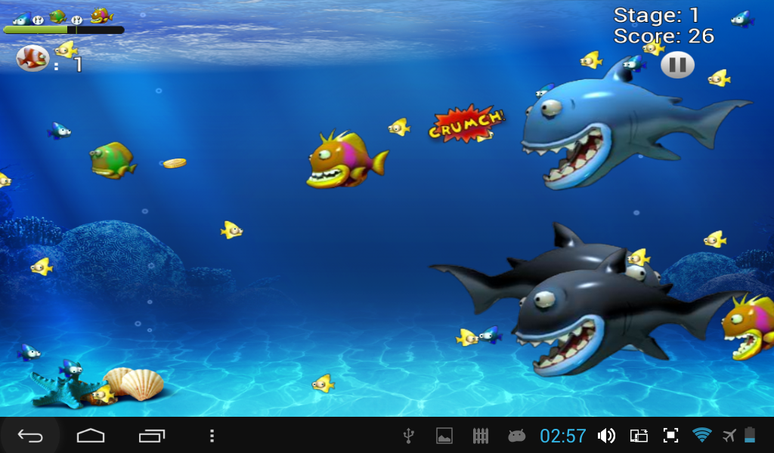

*Feeding Frenzy* shares a similar theme and art style.

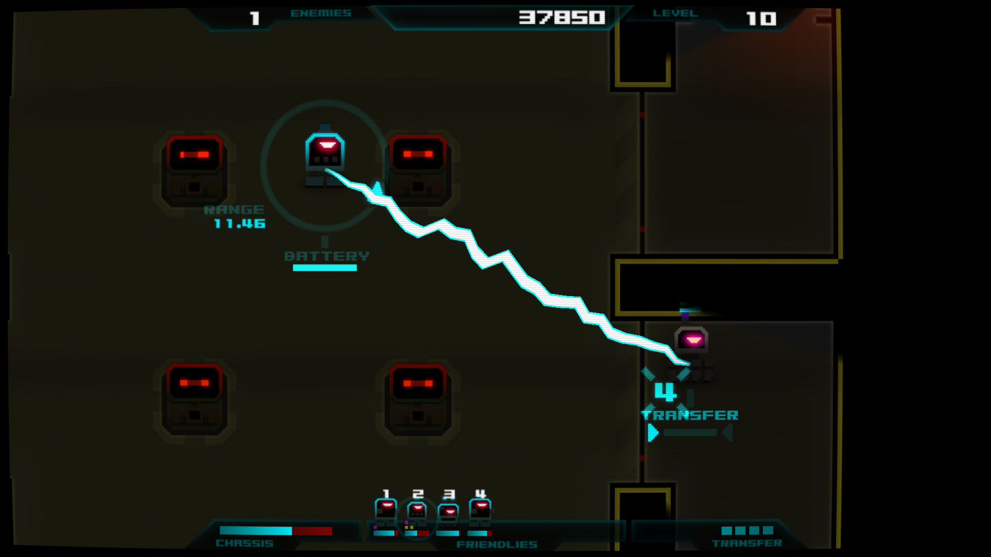

*Droid Assault* shares similar gameplay and mechanics.

Project Plan

Money: Budget Plan

Unity3D will be used as the engine for its ease of use and ability to work deploy to iOS.

|  |  |  |  |  |  |
| --- | --- | --- | --- | --- | --- |
| Engine Licenses | Qty | Price/Month | | Taxes 9.6% | Total |
| Unity3D Pro | 3 | $125/month, 1 year | | $432 | $4,932.00 |
|  |  | |  |  | $4,932.00 |

Note: General Programmer, Gameplay & UX/UI Designer, and QA only need Unity3D.

|  |  |  |  |  |  |
| --- | --- | --- | --- | --- | --- |
| Software Licenses | Qty | | Price/Month | Taxes 9.6% | Total |
| Unity IAP (In-App-Purchases) | 1 | | Free | - | - |
| Unity Ads | 1 | | Free | - | - |
| EarlGray iOS Functional UI Testing Framework | 1 | | Free (Open Source) | - | - |
| Adobe Creative Cloud (Photoshop, Illustrator, After Effects, etc.) | 2 | $49/month, 1 year | | $112.90 | $1,288.90 |

Note: Gameplay & UX/UI Designer and 2D Artist only need the Adobe Creative Cloud.

|  |  |  |  |
| --- | --- | --- | --- |
| Position | Seniority | Pay/Hour | Total |
| Project Manager | Mid-level | $45.00 | $93,600 |
| General Programmer | Senior-level | $55.00 | $114,400 |
| Gameplay & UX/UI Designer | Mid-level | $45.00 | $93,600 |
| 2D Artist | Junior-level | $35.00 | $72,800 |
| QA | Junior-level | $35.00 | $72,800 |
|  |  |  | $447,200 |

Note: 5 people hired for the full duration of the project.

|  |  |  |  |  |  |  |  |  |  |
| --- | --- | --- | --- | --- | --- | --- | --- | --- | --- |
| Device Costs | | | Qty | Operating System | | Price | | Taxes | Total |
| iPhone 7-premiere experience | | | 2 | iOS 10.x | | $649 | | $62.30 | $1,422.61 |
| iPhone 6 | | | 2 | iOS 9.x | | $495 | | $47.52 | $1,085.04 |
|  |  |  | | |  | |  | | $2,507.65 |

Note: 10.X & 9.X iOS has adoption rates of 87.1% and 8.8% = 95.9% of all iPhone iOS.

|  |  |  |  |  |  |
| --- | --- | --- | --- | --- | --- |
| Other Costs |  | Yearly Fee | | Taxes 9.6% | Total |
| Apple iOS Store |  | $99 | | $9.5 | $108.50 |
|  |  | |  |  | $108.50 |

Note: Apple iOS store takes 30% of price of each install/in-app purchase.

|  |  |  |
| --- | --- | --- |
| Total Costs | Total Costs | Project Budget |
| Engine, Software, Salaries, Devices, & Other Costs | $456,037.05 | $611,520.00 |

People: Team/Staffing Plan

Project Nautilus has been given the authority to hire 5 – 6 people, so it will be hiring 5 employees. The following list of positions to hire is in order of priority with the top most position being the most important:

|  |  |  |  |
| --- | --- | --- | --- |
| Position | Seniority | Pay/Hour | Total |
| 1. Project Manager | Mid-level | $45.00 | $93,600 |
| 2. General Programmer | Senior-level | $55.00 | $114,400 |
| 3. Gameplay & UX/UI Designer | Mid-level | $45.00 | $93,600 |
| 4. 2D Artist | Junior-level | $35.00 | $72,800 |
| 5. QA | Junior-level | $35.00 | $72,800 |
|  |  |  | $447,200 |

Staffing Justifications

Project Nautilus will hire a project manager to help keep the team on track and take care of administration so that the rest of the development team can focus on their work. A general programmer will be hired to work in the Unity 3D engine on tools and the technology needed in order to develop the game. A gameplay & UX/UI designer will be working on scripting gameplay mechanics, levels, adding music/sound, and the user interface. A 2D artist will work on all visuals of the game. A QA will be hired to test the game and playtest the gameplay of the game. All hired employees will be hired for the entire length of the project.

Development Methodology

Project Nautilus will be utilizing the Scrum Agile development methodology. The advantages to using an Agile development methodology will allow our team to make changes as they come up through development instead of sticking to a rigid plan. This will allow for additional features, sprint evaluations, product feedback, and also consistent product testing during development to ensure no bugs will exist after the development cycle.

Logistics

Workspace

Project Nautilus will be developed in the main studio. This will allow the team to freely communicate and collaborate on the project and have access to each other’s tools and help with minimal difficulty.

Time zones

Project Nautilus will be developed in the main studio, so there should be no problem setting up meetings or communicating deadlines due to being in the same location/time-zone.

Remote Access

Project Nautilus will be developed in the main studio, so there should be no need for remote access for systems and tools.

Meetings/Deadlines

Due to using the Scrum Agile development methodology, the team will be meeting daily to check up on their work and have monthly milestone deadlines.

Special Consideration

Due to being in the main studio we’ll have to prepare for frequent reports and check-ins on the progress of the project by the main studio.

Roadmap: Development Timeline

* Pre-Production: 2 Months: January – February
  + Employee Hiring Complete
  + Game Concept Complete
  + Game Prototype Complete & Tested
* Production/Full Development: 8 Months: March – October
  + Game Mechanics Tested & Complete
  + Game Technology Tested & Complete
  + Game Development Tested & Complete
  + Art/Sound Assets Tested & Complete
  + Multiple Playtests Complete
  + Apple Certification Complete
  + Required/Featured Systems Tested & Complete
  + PAX West Demo on September 2 – 5, 2017
* Launch/Live: 2 Months: November – December
  + Launch Testing & Support
  + Game Complete

Required Systems & Features

The required systems and features are expected to be integrated and useable as created through the production/development cycle and will be completed by the launch/live date.

Assets

The assets needed for the game will include art, sound, music, and scripts needed to make the game. The assets needed for the game will be created during the production/development cycle of the game and will be complete by launch/live date.

Demos/Shows/PR Impact/Dates

Reality Games will be providing the marketing materials and promotion for Project Nautilus and the team will be able to provide pictures/video/content as needed or requested. As the holidays and launch/live date come closer we will have to schedule for additional time needed in order to support demos and shows. Additionally, to get the game approved for the Apple iOS Store it will take an average of 6 days before the game is listed.

Research shows that people aged 25 – 34 are most likely to own an iPhone, followed closely by the 18 – 24 age group. The arcade genre ranks in the top 5 iOS game genres in the United States, China, Spain, and Russia, making it a safe genre for a guaranteed audience, but potentially a game with a lot of competition. For this reason, we should plan on going to events like PAX in order to gain exposure and build a community around the game pre-launch.